MACH4METAL

metalworking machinery
Transito 21
6909 DA BABBERICH Netherlands
Tel. +31 (0)316-247123
Fax: +31 (0)316-247956
info@mach4metal.com
www.mach4metal.com

Bank No : 66.52.13.883
IBAN : NL33 INGB 0665 2138 83
BIC : INGBNL2A

Servo mechanical CNC Press brake
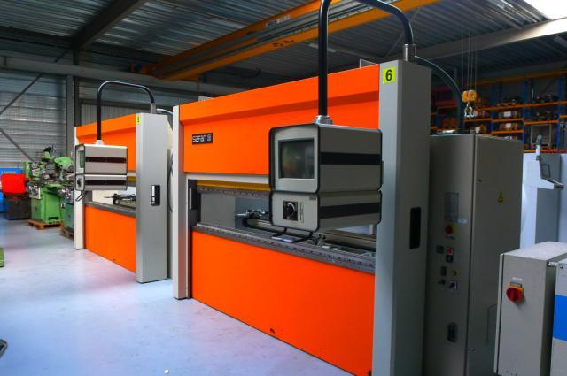
- Merk : Safan Darley HOLLAND
- Type : SMK 50 - 2550
- Mach.No : MK 282
- Yom : 1998

- Max. bending length : 2.550
- Between column : 2.550
- Max. force Tonnage : 50
- Stroke upper beam : 275
- Stroke lower beam : 160

- Approch speed : 90 mm/sec.
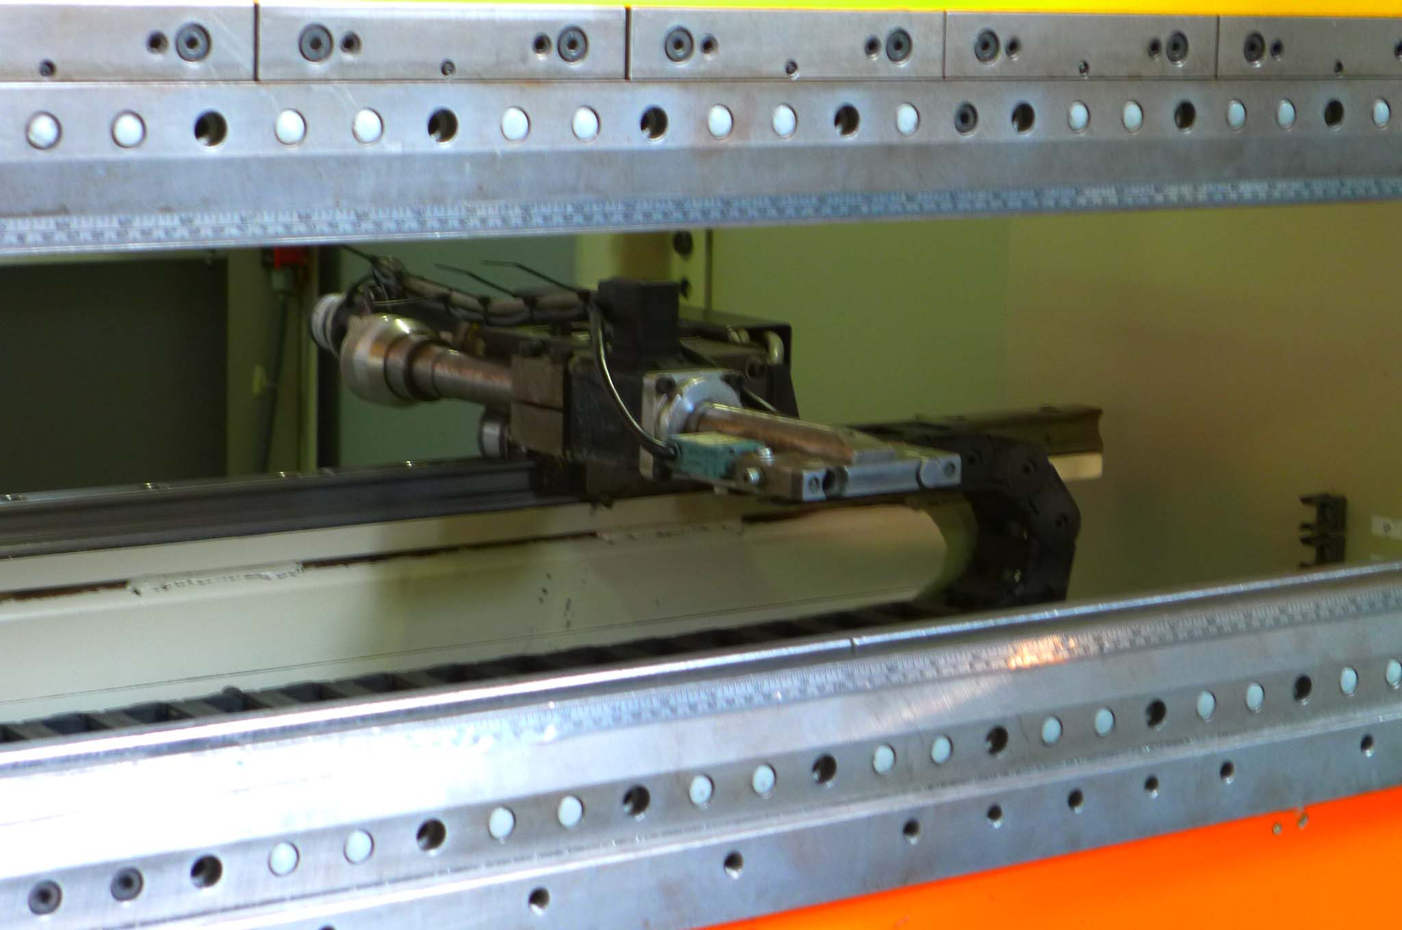
- Pressing speed : 20 mm/sec.
- Return speed : 90 mm/sec.
- Speed lower beam : 15 mm/sec.

- TS 1 Touch screen CNC Control
- X axis : 550 mm
- X axis speed : 400 mm/min.
- Extra axis : R + Z
- Tool system:

- Power : 9 kW
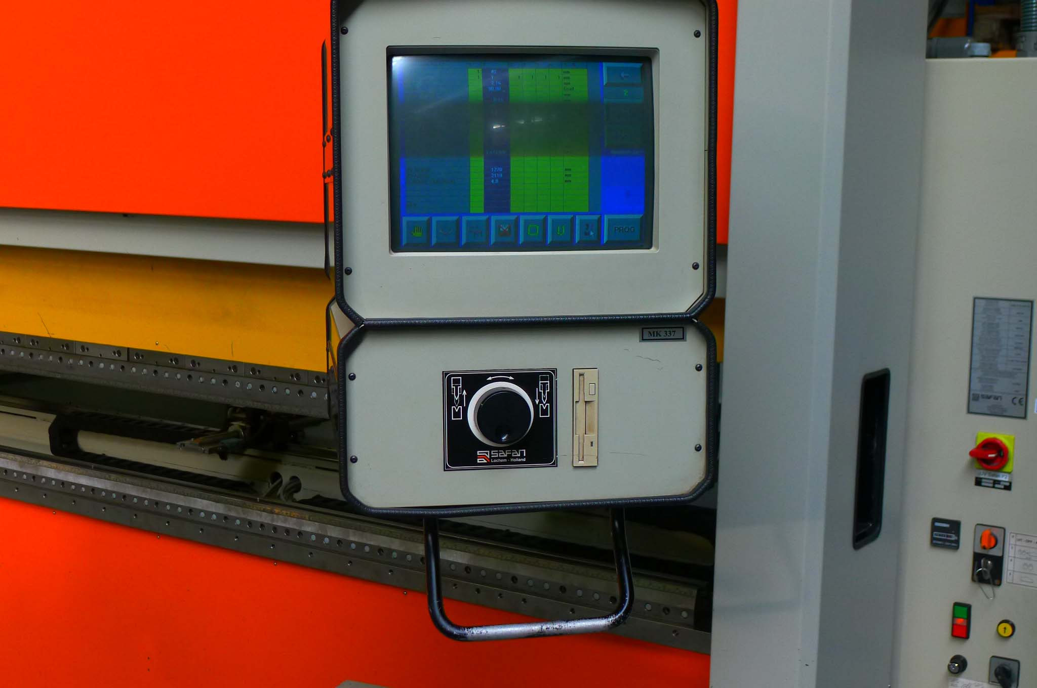
- Lower beam : 1.5 kW

- Width : 2.550
- Height : 2.620
- Depth : 1.850
- Weight : 6.000

- Servo mechanical Press brake
- High safety / Innovative / Ecological

Please Note: The above information has been obtained to the best of our ability and belief from, and from the manufacturers where possible. It is given in good faith, but its accuracy can not be guaranteed. Accordingly, it will not form a representation or constitute contractual terms. We advise you to check any vital details!

